***PERFECT PEGS***

***Ceramic Firing Pegs***

Perfect Pegs, ceramic firing pegs, hold crowns and bridges in place in a porcelain furnace. They provide stability and allow for close placement. Perfect Pegs are excellent for use with Emax and Zirconia restorations.

***Perfect Pegs Advantages:***

* Excellent for use with Emax and Zirconia restorations
* Allow close placement for crowns & bridges
* Provide stability
* Can be fired up to 2200° Fahrenheit
* Come in 3 different shapes

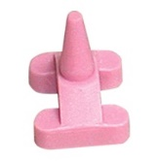

**Item # 112 For Small Anteriors / Small Bicuspids** (Set of 6)

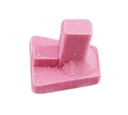

**Item #114 For Small Molars** (Set of 6)

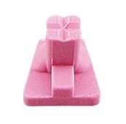

**Item #116 For Large Molars** **/ Large Bicuspids** (Set of 6)

**Item #119 Assortment** (Set of 12)

For Small Anteriors / Small Bicuspids (4 ea.); For Small Molars (4 ea.);

For Large Molars / Large Bicuspids (4 ea.)

