BRISTLE BRUSHES - #11 SOFT HP MOUNTED
High quality natural bristle brushes ideal for polishing e.max, Lava and full contour zirconia restorations, as well as for polishing precious and non-precious alloys. Diameter 11/16".

Item# 530 (Box of 12)
Suggested Retail Price $10.95

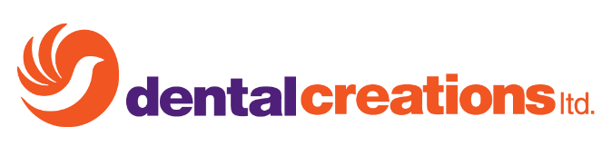
Item# 531 (Box of 144)
Suggested Retail Price $95.95

